**Key Question: How have the demographic changes in Boston affected local elections over the past decade?**

**Part 1: Examining the Demographic Changes in Boston over the Past Decade**

Using census data, we give an overview of how the demographics have changed in Boston in the past decade. Note that this analysis is not on the precinct level, since the data used is from in-between census years using the American Community Survey. Additionally, this data is only a rough estimate of the actual population for this same reason.

First, we examine the raw numbers of white, Black, and Asian populations for the years 2010, 2015, and 2019.

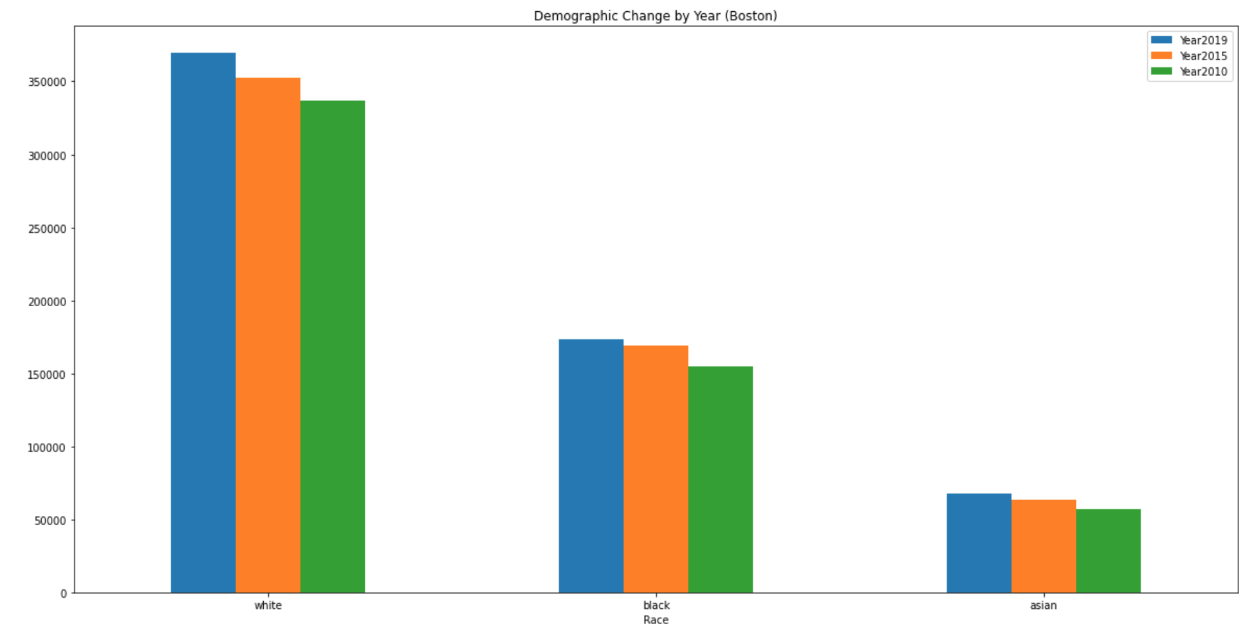

Here, we find that each of these demographics have grown in Boston throughout the past 10 years.

We also visualize the growth of Black and Asian populations using the following charts:

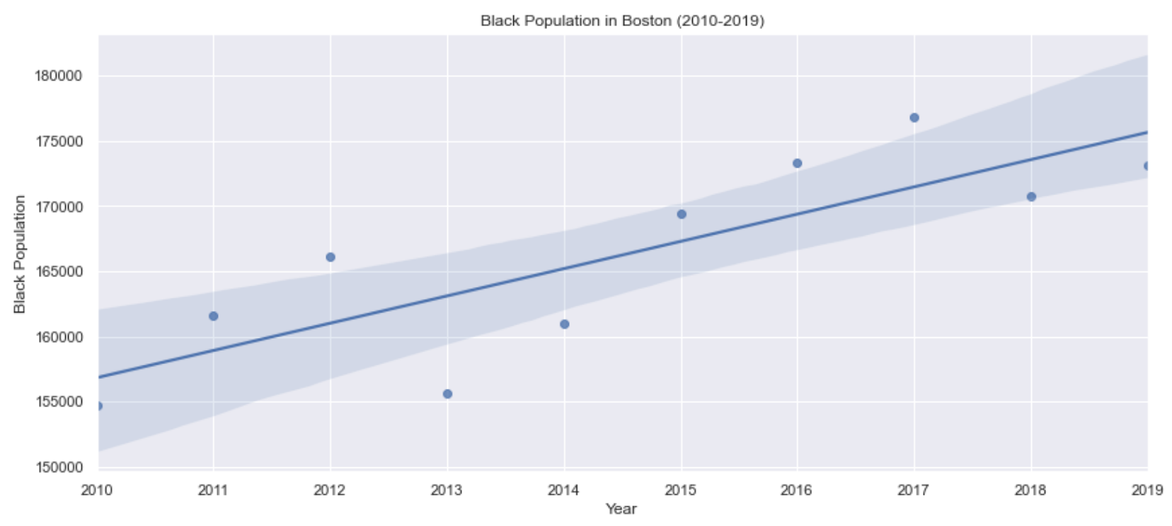

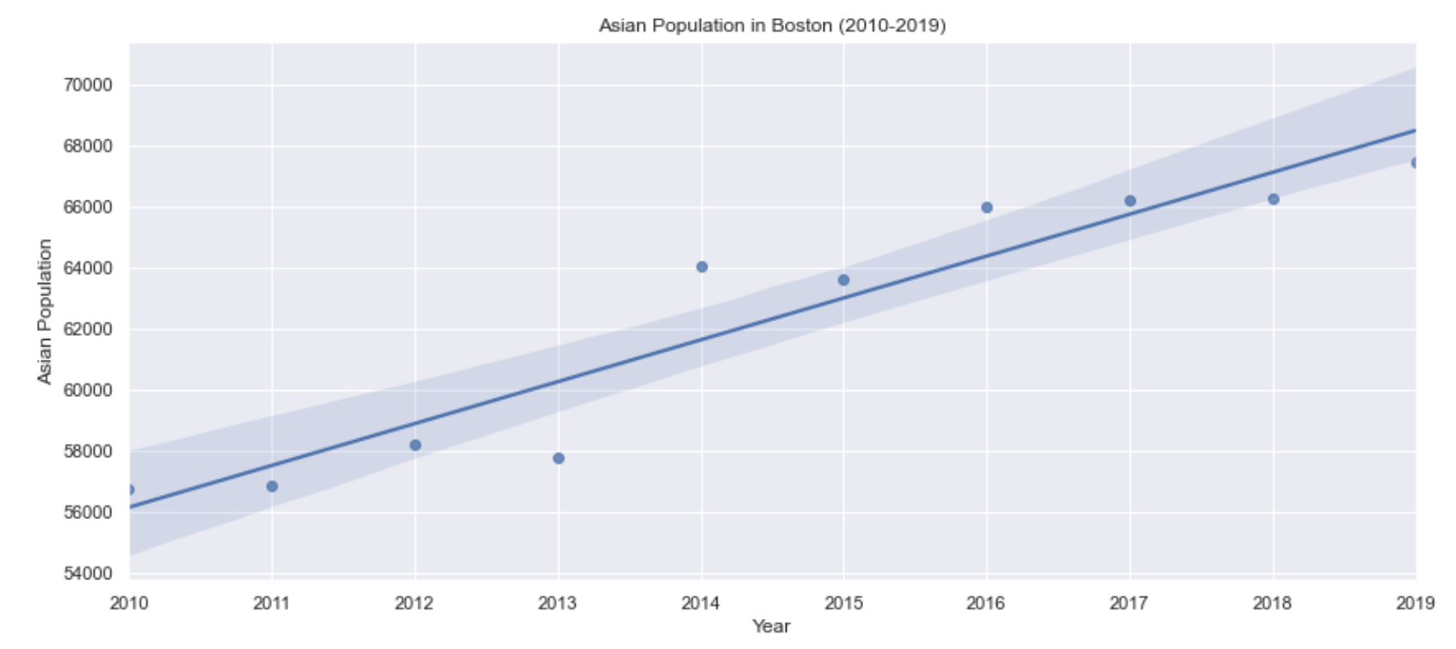

Clearly, both demographics are on an upward trend of growth. In the past 10 years, the Black population in Boston has grown by around 20,000 people, while the Asian population in Boston has grown by approximately 12,000 people.

Now, we will examine the performance of Black candidates over key elections in the past decade. While we cannot determine causation, we will be able to examine if there is any correlation between the growth in Black population and the performance of these candidates over the years.

**Part 2: Regression Analysis of City Council Voter Turnout Percentages by a given Race’s Percentage in Each Precinct**

In this section, we examine whether or not there is any correlation between voter turnout and the percentage of a given race in each precinct. For this analysis, we examine the turnouts of the City Council elections of the years 2011 to 2019.

|  |  |  |  |
| --- | --- | --- | --- |
| **Year** | **Race/Ethnicity** | **Description** | **Graph** |
| 2011 | Asian | We find a slight negative correlation between Asian percentage and percent Turnout for CC Election 2011, however, it is not significant. |  |
| 2013 | Asian | We find a slight negative correlation between Asian percentage and percent Turnout for CC Election 2013. |  |
| 2015 | Asian | We find a slight negative correlation between Asian percentage and percent Turnout for CC Election 2015, however, it is not significant. |  |
| 2017 | Asian | We find a slight negative correlation between Asian percentage and percent Turnout for CC Election 2017, however, it is not significant. |  |
| 2019 | Asian | We find no real correlation between Asian percentage and percent Turnout for CC Election 2019. |  |
| 2011 | Black | We find no real correlation between Black percentage and percent Turnout for CC Election 2011. |  |
| 2013 | Black | We find no real correlation between Black percentage and percent Turnout for CC Election 2013. |  |
| 2015 | Black | We find a slight positive correlation between Black percentage and percent Turnout for CC Election 2015, however, it is not significant. |  |
| 2017 | Black | We find no real correlation between Black percentage and percent Turnout for CC Election 2017. |  |
| 2019 | Black | We find no real correlation between Black percentage and percent Turnout for CC Election 2019. |  |
| 2011 | Hispanic | We find a slight negative correlation between Hispanic percentage and percent Turnout for CC Election 2011, however, it is not significant. |  |
| 2013 | Hispanic | We find no real correlation between Hispanic percentage and percent Turnout for CC Election 2013. |  |
| 2015 | Hispanic | We find no real correlation between Hispanic percentage and percent Turnout for CC Election 2015. |  |
| 2017 | Hispanic | We find no real correlation between Hispanic percentage and percent Turnout for CC Election 2017. |  |
| 2019 | Hispanic | We find no real correlation between Hispanic percentage and percent Turnout for CC Election 2019. |  |
| 2011 | White | We find no real correlation between White percentage and percent Turnout for CC Election 2011. |  |
| 2013 | White | We find a slight positive correlation between White percentage and percent Turnout for CC Election 2013, however, it is not significant. |  |
| 2015 | White | We find no real correlation between White percentage and percent Turnout for CC Election 2015. |  |
| 2017 | White | We find no real correlation between White percentage and percent Turnout for CC Election 2017. |  |
| 2019 | White | We find no real correlation between White percentage and percent Turnout for CC Election 2019. |  |

Summary of results:

* For CC 2011 through CC 2017, we found that precincts with higher Asian populations tended to have lower voter turnout. However, in 2019, this changed, as we no longer found a negative correlation.
  + This coincides with the growing Asian population in Boston, but causation cannot be determined.
* We found no real relationship between precincts with high Black populations and voter turnout, except perhaps in 2015, when there was a slight positive correlation between the two.
* We found no correlation between precincts with high Hispanic populations and voter turnout.
* We found no correlation between precincts with high White populations and voter turnout.

**Part 3: The Performance of Key Black Candidates Over the Past Decade**

In this section, we will be examining the following elections and Black candidates while keeping in mind our findings in Part 1 that the Black population in Boston has been growing over the past decade:

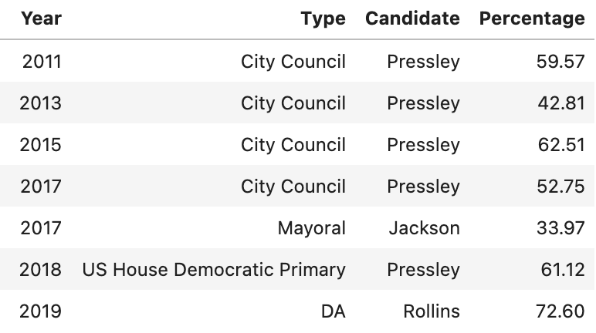

Visualizing their performance:

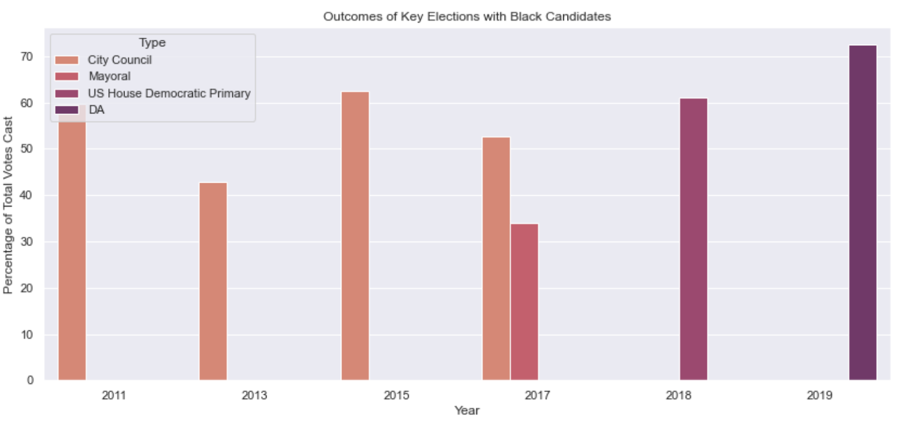

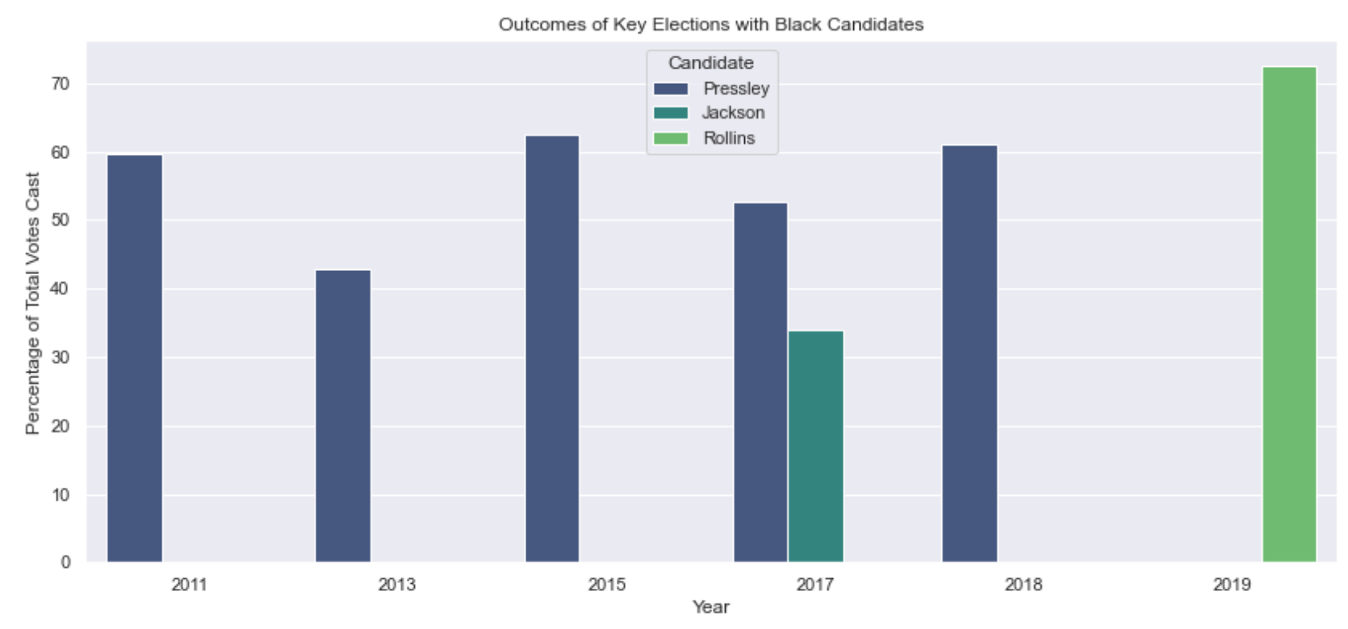

From these bar charts, we find no clear trend in the performance of Black candidates across each year.

However, we also fit a regression line to determine if there has been any trend:

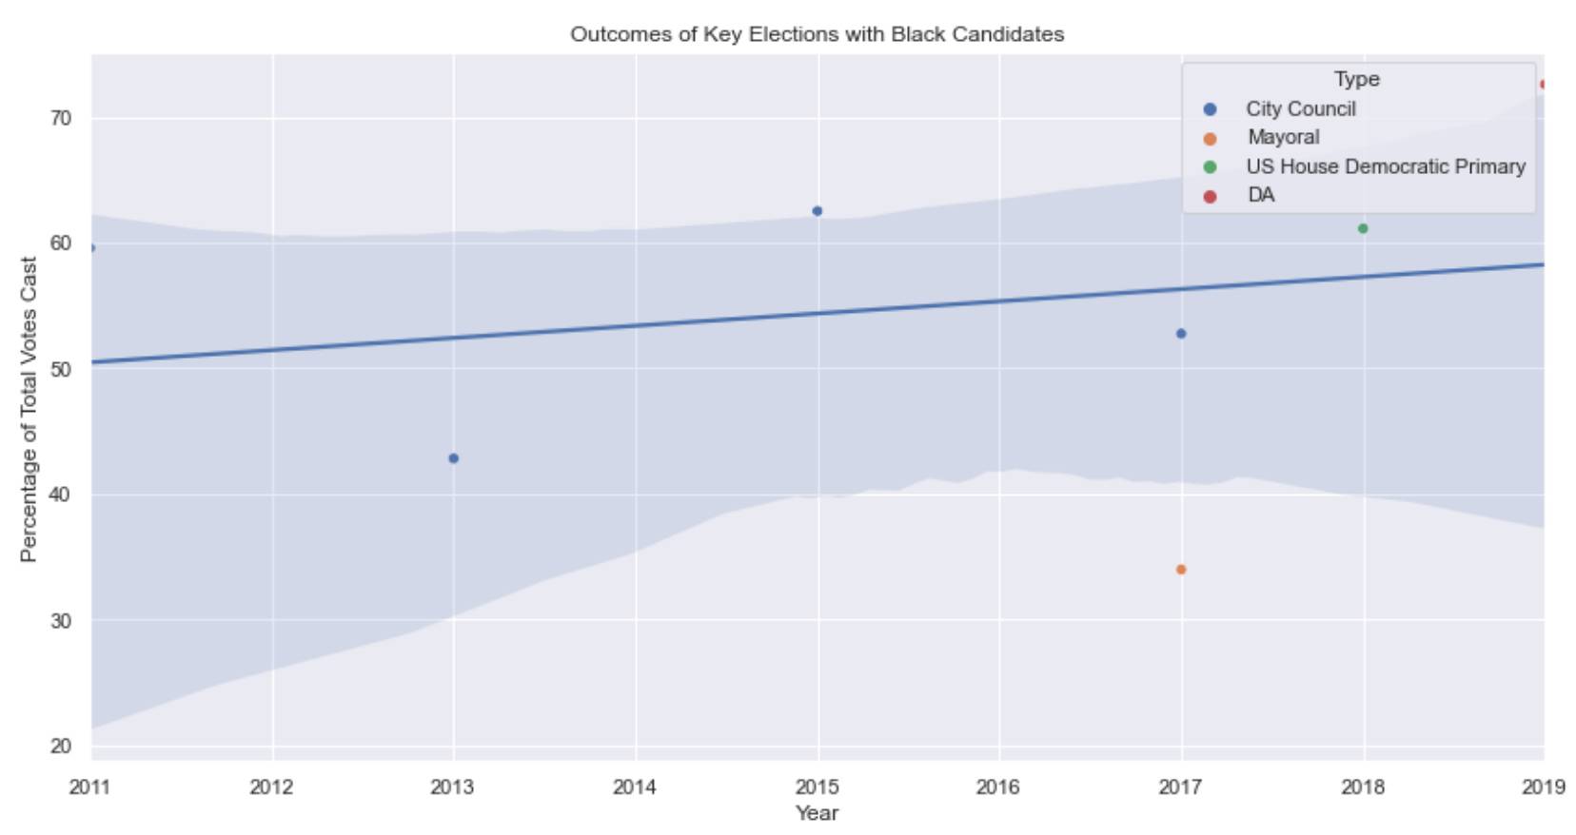

As we can see, there has been a very slight positive trend in the performance of Black candidates over the past decade, however it is not significant. This begs the question of whether or not this has any relationship with the growing Black population in Boston, as we saw from our earlier analysis.